**NRTC Initial Reconciliation Report for 2021**

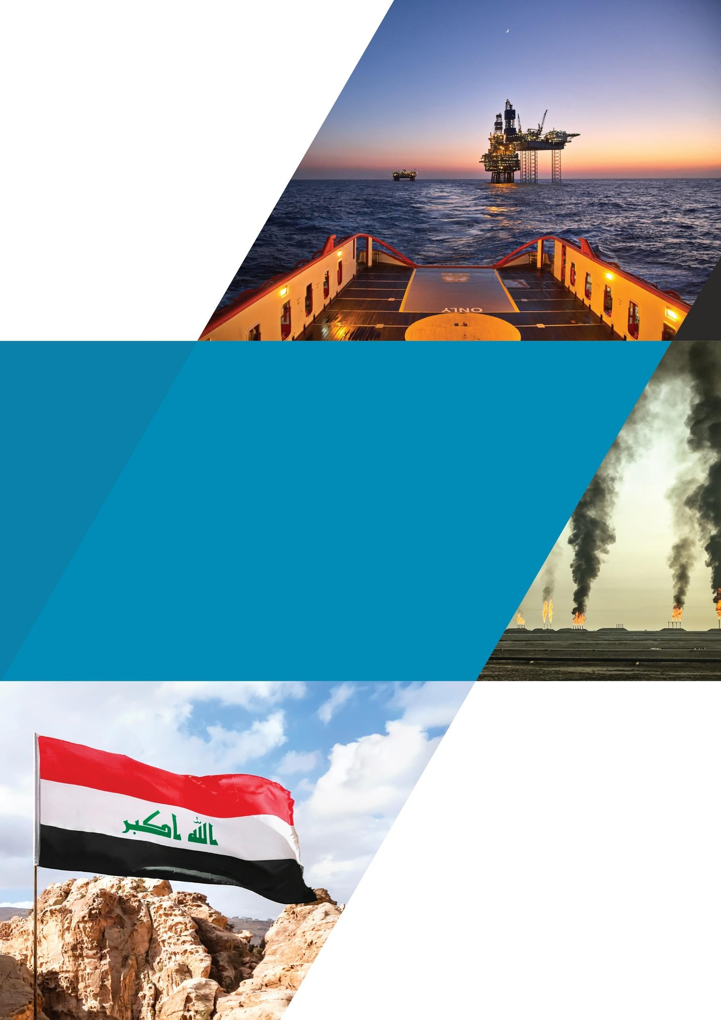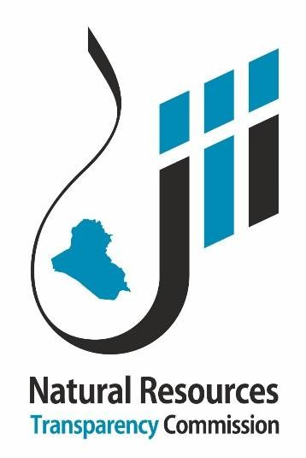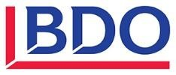

Initial Reconciliation Report 2021

December 2023

**This report has been prepared at the request of the Multi-Stakeholder Group (MSG) in charge of the implementation of the Extractive Industries Transparency Initiative in Iraq. The opinions expressed in the report are those of the Independent Administrator and the report has been approved by the MSG. This report has been prepared exclusively for use by the NRTC and must not be used by other parties, nor for any purposes other than those for which it is intended.**

**TABLE OF CONTENTS**

1. BUYER COMPANIES 6
   1. Crude oil buyers 6
   2. Petroleum products buyers 8
2. INTERNATIONAL OIL COMPANIES 10
   1. Crude oil lifted 10
   2. Tax receipts 12

**LIST OF TABLES**

Table 1: Summary of initial discrepancies (Crude oil Sales) 6

Table 2: Initial Discrepancies by Crude Oil Buyer 6

Table 3: Summary of Initial Discrepancies (Petroleum Products) 8

Table 4: Initial Discrepancies by Petroleum Products Buyer 8

Table 5: Summary of Initial Discrepancies (Crude oil lifted In-Kind) 10

Table 6: Oil Lifted by IOCs initial differences by Company 10

Table 7: Detail of IOCs’ Taxes by Revenue Stream 12

Table 8: Detail of IOCs’ Taxes by Oil Field 12

Table 9: Detail of IOCs’ Taxes by Province 12

**LIST OF ABBREVIATIONS**

|  |  |
| --- | --- |
| bbl | Barrel |
| CIT | Corporate income tax |
| IOC | International oil company |
| MoF | Ministry of Finance |
| NRTC | Natural Resources Transparency Commission |
| PIT | Personal income tax |
| RT | Reporting template |
| SOMO | State Oil Marketing Company |
| SS | Social security |
| WHT | Withholding tax |
| WP | Work permit |

# BUYER COMPANIES

We present below the reconciliation between the State Oil Marketing Company (SOMO) and companies that bought crude oil and petroleum products during 2021.

## Crude oil buyers

The table below summarises the initial discrepancies of crude oil sales between SOMO and buyer companies.

**TABLE 1: SUMMARY OF INITIAL DISCREPANCIES (CRUDE OIL SALES)**

|  |  |  |  |  |  |  |  |  |
| --- | --- | --- | --- | --- | --- | --- | --- | --- |
| **Initial reconciliation** | **SOMO** | | **Crude oil buyers** | | **Discrepancies** | | | |
| **Quantity (bbl)** | **Amount (USD)** | **Quantity (bbl)** | **Amount (USD)** | **Quantity (bbl)** | **%** | **Amount (USD)** | **%** |
| Crude oil buyers that submitted their RTs | 128,547,183 | 8,788,748,510 | 127,641,760 | 8,652,226,206 | 905,423 | 0.71% | 136,522,304 | 1.58% |
| Crude oil buyers that did not submit their RTs yet | 822,051,065 | 56,536,116,889 | - | - | 822,051,065 | 100.00% | 56,536,116,889 | 100.00% |
| **Total** | **950,598,248** | **65,324,865,400** | **127,641,760** | **8,652,226,206** | **822,956,488.00** | **644.74%** | **56,672,639,194** | **655.01%** |

Details of the initial discrepancies are presented below by crude oil buyer:

**TABLE 2: INITIAL DISCREPANCIES BY CRUDE OIL BUYER**

|  |  |  |  |  |  |  |  |
| --- | --- | --- | --- | --- | --- | --- | --- |
| **N°** | **Crude oil buyer** | **SOMO** | | **Crude oil buyers** | | **Discrepancies** | |
| **Quantity (bbl)** | **Amount (USD)** | **Quantity (bbl)** | **Amount (USD)** | **Quantity (bbl)** | **Amount (USD)** |
| **Crude Oil buyers that submitted their RTs** | | **128,547,183** | **8,788,748,510** | **127,641,760** | **8,652,226,206** | **905,423** | **136,522,304** |
| 1 | GS CALTEX SINGAPORE PTE. LTD | 42,842,797 | 2,916,156,771 | 42,902,655 | 2,852,346,189 | (59,858) | 63,810,583 |
| 2 | NAYARA ENERGY LIMITED | 28,469,567 | 1,933,690,606 | 28,469,567 | 1,933,690,606 | - | - |
| 3 | CHEVRON | 23,445,425 | 1,589,127,080 | 23,445,425 | 1,589,127,080 | - | - |
| 4 | HPCL-MITTAL ENERGY LIMITED | 13,894,182 | 975,781,795 | 13,894,182 | 975,781,795 | - | - |
| 5 | The Egyptian General Petroleum Corporation (EGPC) | 9,876,066 | 690,288,237 | 9,876,066 | 690,288,237 | - | - |
| 6 | REPSOL TRADING S.A | 10,019,146 | 683,704,021 | 9,053,865 | 610,992,299 | 965,281 | 72,711,722 |
| **Crude oil buyers that did not submit their RTs yet** | | **822,051,065** | **56,536,116,889** | **-** | **-** | **822,051,065** | **56,536,116,889** |
| 7 | INDIAN OIL (CHENNAI PETROLEUM CORPORATION LTD) | 135,320,200 | 9,331,566,455 | - | - | 135,320,200 | 9,331,566,455 |
| 8 | China International United Petroleum and Chemicals Co. Ltd. (UNIPEC) | 130,914,735 | 9,128,936,067 | - | - | 130,914,735 | 9,128,936,067 |

|  |  |  |  |  |  |  |  |
| --- | --- | --- | --- | --- | --- | --- | --- |
| **N°** | **Crude oil buyer** | **SOMO** | | **Crude oil buyers** | | **Discrepancies** | |
| **Quantity (bbl)** | **Amount (USD)** | **Quantity (bbl)** | **Amount (USD)** | **Quantity (bbl)** | **Amount (USD)** |
| 9 | SINOCHEM | 105,237,087 | 7,252,900,474 | - | - | 105,237,087 | 7,252,900,474 |
| 10 | RELIANCE INDUSTRIES LIMITED(RIL) | 82,945,203 | 5,591,328,789 | - | - | 82,945,203 | 5,591,328,789 |
| 11 | Turkish Petroleum Refineries Corp. (TUPRAS) TURKEY | 58,917,068 | 4,020,622,475 | - | - | 58,917,068 | 4,020,622,475 |
| 12 | CHINA ZHENHUA OIL CO. LTD (SINOSURE) | 47,725,895 | 3,314,150,177 | - | - | 47,725,895 | 3,314,150,177 |
| 13 | MOTOR OIL HELLAS CORINTH REFINERIES S.A | 30,146,184 | 2,023,498,536 | - | - | 30,146,184 | 2,023,498,536 |
| 14 | SHELL | 28,456,135 | 1,998,820,430 | - | - | 28,456,135 | 1,998,820,430 |
| 15 | BHARAT PETROLEUM CORPORATION LTD. | 28,543,750 | 1,957,670,240 | - | - | 28,543,750 | 1,957,670,240 |
| 16 | MANGALORE REFINERY & PETROCHEMICALS LIMITED. | 17,677,143 | 1,244,358,924 | - | - | 17,677,143 | 1,244,358,924 |
| 17 | VALERO MARKETING & SUPPLY COMPANY | 19,037,203 | 1,231,820,651 | - | - | 19,037,203 | 1,231,820,651 |
| 18 | HINDUSTAN PETROLEUM CORPORATION LIMITED | 17,454,785 | 1,195,429,643 | - | - | 17,454,785 | 1,195,429,643 |
| 19 | PETROCHINA INTERNATIONAL CO. | 16,589,273 | 1,172,046,042 | - | - | 16,589,273 | 1,172,046,042 |
| 20 | MARATHON PETROLEUM SUPPLY LLC | 14,627,382 | 1,012,305,037 | - | - | 14,627,382 | 1,012,305,037 |
| 21 | ExxonMobil Sales And Supply Corporation Gallows | 14,385,335 | 960,441,097 | - | - | 14,385,335 | 960,441,097 |
| 22 | SK ENERGY CO. LTD | 11,714,526 | 782,323,540 | - | - | 11,714,526 | 782,323,540 |
| 23 | BHARAT OMAN REFINERIES LIMITED | 10,698,785 | 747,241,945 | - | - | 10,698,785 | 747,241,945 |
| 24 | China Offshore Oil (Singapore) International PTE. LTD. | 10,334,729 | 736,168,805 | - | - | 10,334,729 | 736,168,805 |
| 25 | SARAS TRADING SA | 8,232,710 | 579,640,845 | - | - | 8,232,710 | 579,640,845 |
| 26 | HELLENIC PETROLEUM S.A. | 8,003,789 | 547,871,819 | - | - | 8,003,789 | 547,871,819 |
| 27 | ENI TRADING & SHIPPING SPA - ITALY | 7,026,023 | 461,761,438 | - | - | 7,026,023 | 461,761,438 |
| 28 | TOTSA TOTAL OIL TRADING SA | 4,916,150 | 321,489,787 | - | - | 4,916,150 | 321,489,787 |
| 29 | FORMOSA PETROCHEMICAL CORPORATION (FPCC) | 2,913,051 | 206,415,291 | - | - | 2,913,051 | 206,415,291 |
| 30 | IPLOM INERNATIONAL SA | 2,960,752 | 191,596,707 | - | - | 2,960,752 | 191,596,707 |
| 31 | HENGLI | 1,926,475 | 154,570,722 | - | - | 1,926,475 | 154,570,722 |
| 32 | SHANDONG DONGMING | 1,921,878 | 136,589,791 | - | - | 1,921,878 | 136,589,791 |
| 33 | RONGSHENG PETROCHEMICAL | 1,550,000 | 115,671,850 | - | - | 1,550,000 | 115,671,850 |
| 34 | PETROBRAS GLOBAL TRADING B.V. | 990,520 | 65,173,244 | - | - | 990,520 | 65,173,244 |
| 35 | JORDAN PETROLEUM REFINERY CO. LTD. | 884,299 | 53,706,069 | - | - | 884,299 | 53,706,069 |
| **Total** |  | **950,598,248** | **65,324,865,400** | **127,641,760** | **8,652,226,206** | **822,956,488** | **56,672,639,194** |

## Petroleum products buyers

The table below summarises the initial discrepancies of petroleum products sales between SOMO and buyer companies.

**TABLE 3: SUMMARY OF INITIAL DISCREPANCIES (PETROLEUM PRODUCTS)**

|  |  |  |  |  |  |  |  |  |
| --- | --- | --- | --- | --- | --- | --- | --- | --- |
| **Initial reconciliation** | **SOMO** | | **Petroleum products buyers** | | **Discrepancies** | | | |
| **Quantity (bbl)** | **Amount (USD)** | **Quantity (bbl)** | **Amount (USD)** | **Quantity (bbl)** | **%** | **Amount (USD)** | **%** |
| Petroleum products buyers that submitted their RTs | 205,813 | 124,782,874 | 205,813 | 124,782,874 | - | 0.00% | - | 0.00% |
| Petroleum products buyers that did not submit their RTs yet | 9,179,676 | 3,987,805,922 | - | - | 9,179,676 | 100.00% | 3,987,805,922 | 100.00% |
| **Total** | **9,385,489** | **4,112,588,796** | **205,813** | **124,782,874** | **9,179,675.53** | **4460.20%.** | **3,987,805,922** | **3195.80%** |

Details of the initial discrepancies are presented below by petroleum products buyer:

**TABLE 4: INITIAL DISCREPANCIES BY PETROLEUM PRODUCTS BUYER**

|  |  |  |  |  |  |  |  |
| --- | --- | --- | --- | --- | --- | --- | --- |
| **N°** | **Petroleum Products Buyer** | **SOMO** | | **Petroleum products buyers** | | **Discrepancies** | |
| **Quantity (bbl)** | **Amount (USD)** | **Quantity (bbl)** | **Amount (USD)** | **Quantity (bbl)** | **Amount (USD)** |
| **Crude oil buyers submitting their RTs** | | **205,813** | **124,782,874** | **205,813** | **124,782,874** | **-** | **-** |
| 1 | EnlIL Energy | 205,813 | 124,782,874 | 205,813 | 124,782,874 | - | - |
| **Crude oil buyers not submitting their RTs** | | **9,179,676** | **3,987,805,922** | **-** | **-** | **9,179,676** | **3,987,805,922** |
| 2 | RELIANCE Industries Company | 2,123,868 | 838,868,692 | - | - | 2,123,868 | 838,868,692 |
| 3 | Shuaa taqa Petrol services Company | 1,681,305 | 821,037,916 | - | - | 1,681,305 | 821,037,916 |
| 4 | Chevron AL KHALIJ | 1,898,534 | 771,818,080 | - | - | 1,898,534 | 771,818,080 |
| 5 | Manabaa wassit Company | 908,842 | 424,548,142 | - | - | 908,842 | 424,548,142 |
| 6 | PTT International Trading | 542,655 | 289,695,702 | - | - | 542,655 | 289,695,702 |
| 7 | LITASCO middle East | 599,975 | 223,198,753 | - | - | 599,975 | 223,198,753 |
| 8 | Shoroq Al Anouar Company | 333,062 | 142,563,992 | - | - | 333,062 | 142,563,992 |
| 9 | Ministry of Energy and Water Lebanon | 290,468 | 136,547,821 | - | - | 290,468 | 136,547,821 |
| 10 | VENANDI Global company | 283,341 | 122,771,313 | - | - | 283,341 | 122,771,313 |
| 11 | LARAAK OIL trading | 144,379 | 71,993,099 | - | - | 144,379 | 71,993,099 |
| 12 | Aramco Trading Fujairah | 146,534 | 70,311,532 | - | - | 146,534 | 70,311,532 |
| 13 | Layali Sahab Company | 70,786 | 33,407,446 | - | - | 70,786 | 33,407,446 |

|  |  |  |  |  |  |  |  |
| --- | --- | --- | --- | --- | --- | --- | --- |
| **N°** | **Petroleum Products Buyer** | **SOMO** | | **Petroleum products buyers** | | **Discrepancies** | |
| **Quantity (bbl)** | **Amount (USD)** | **Quantity (bbl)** | **Amount (USD)** | **Quantity (bbl)** | **Amount (USD)** |
| 14 | Djabal Asoued Company | 78,881 | 16,294,769 | - | - | 78,881 | 16,294,769 |
| 15 | GUNVOR | 25,785 | 14,324,796 | - | - | 25,785 | 14,324,796 |
| 16 | Nassim Brari Company | 48,879 | 10,046,638 | - | - | 48,879 | 10,046,638 |
| 17 | Wadi Company Ltd | 2,383 | 377,231 | - | - | 2,383 | 377,231 |
| **Total** |  | **9,385,489** | **4,112,588,796** | **205,813** | **124,782,874** | **9,179,676** | **3,987,805,922** |

# INTERNATIONAL OIL COMPANIES

## Crude oil lifted

The table below summarises the initial discrepancies between SOMO and international oil companies (IOCs) in crude oil lifted in lieu of cost recovery and remuneration fees.

**TABLE 5: SUMMARY OF INITIAL DISCREPANCIES (CRUDE OIL LIFTED IN-KIND)**

|  |  |  |  |  |  |  |  |  |
| --- | --- | --- | --- | --- | --- | --- | --- | --- |
| **Initial reconciliation** | **SOMO** | | **IOCs** | | **Discrepancies** | | | |
| **Quantity (bbl)** | **Amount (USD)** | **Quantity (bbl)** | **Amount (USD)** | **Quantity (bbl)** | **%** | **Amount (USD)** | **%** |
| IOCs that submitted their RTs | 94,757,385 | 6,425,233,165 | 89,631,040 | 6,056,859,535 | 5,126,345 | 5.72% | 368,373,630 | 6.08% |
| IOCs that did not submit their RTs yet | 55,442,888 | 3,789,554,373 | - | - | 55,442,888 | 100.00% | 3,789,554,373 | 100% |
| **Total** | **150,200,273** | **10,214,787,538** | **89,631,040** | **6,056,859,535** | **60,569,233** | **67.58%** | **4,157,928,003** | **68.65%** |

Details of the initial discrepancies are presented below by IOC:

**TABLE 6: OIL LIFTED BY IOCS INITIAL DIFFERENCES BY COMPANY**

|  |  |  |  |  |  |  |  |
| --- | --- | --- | --- | --- | --- | --- | --- |
| **N°** | **IOC** | **SOMO** | | **IOCs** | | **Discrepancies** | |
| **Quantity (bbl)** | **Amount (USD)** | **Quantity (bbl)** | **Amount (USD)** | **Quantity (bbl)** | **Amount (USD)** |
| **IOCs that submitted their RTs** | | **94,757,385** | **6,425,233,165** | **89,631,040** | **6,056,859,535** | **5,126,345** | **368,373,630** |
| 1 | PETROCHINA IRAQ OPERATIONS | 26,347,936 | 1,777,657,985 | 26,347,936 | 1,777,657,985 | - | - |
| 2 | BP | 16,669,423 | 1,102,467,883 | 16,669,423 | 1,102,467,883 | - | - |
| 3 | TURKISH PETROLEUM OVERSEAS COMPANY LIMITED | 4,008,391 | 273,853,761 | 4,008,391 | 273,853,761 | - | - |
| 4 | ITOCHU OIL EXPLONATION IRAQ (B.V.) | 2,929,256 | 208,790,652 | 2,929,256 | 208,790,652 | - | - |
| 5 | EXXON MOBIL IRAQ LIMITED | 2,922,007 | 202,946,423 | 2,922,007 | 202,946,423 | - | - |
| 6 | ENI IRAQ B.V. | 12,843,960 | 908,638,137 | 7,717,615 | 541,017,831 | 5,126,345 | 367,620,306 |
| 7 | CNOOC IRAQ LIMITED | 11,349,773 | 776,998,967 | 11,349,773 | 776,245,644 | - | 753,324 |
| 8 | PETRONAS | 10,017,984 | 659,537,502 | 10,017,984 | 659,537,502 | - | - |
| 9 | KUWAIT ENERGY IRAQ OPERATIONS | 2,794,157 | 201,204,136 | 2,794,157 | 201,204,136 | - | - |
| 10 | JAPEX GARRAF LTD | 2,913,984 | 179,430,526 | 2,913,984 | 179,430,526 | - | - |

|  |  |  |  |  |  |  |  |
| --- | --- | --- | --- | --- | --- | --- | --- |
| **N°** | **IOC** | **SOMO** | | **IOCs** | | **Discrepancies** | |
| **Quantity (bbl)** | **Amount (USD)** | **Quantity (bbl)** | **Amount (USD)** | **Quantity (bbl)** | **Amount (USD)** |
| 11 | DRAGON OIL (BLOCK 9) LIMITED | 1,001,885 | 71,329,203 | 1,001,885 | 71,329,203 | - | - |
| 12 | PT PERTAMINA IRAK | 958,629 | 62,377,989 | 958,629 | 62,377,989 | - | - |
| **IOCs that did not submit their RTs yet** | | **55,442,888** | **3,789,554,373** | **-** | **-** | **55,442,888** | **3,789,554,373** |
| 13 | LUKOIL MID - EAST LIMITED | 13,786,512 | 938,778,017 | - | - | 13,786,512 | 938,778,017 |
| 14 | BOC | 8,499,434 | 527,533,759 | - | - | 8,499,434 | 527,533,759 |
| 15 | AL WAHA PETROLEUM CO. LTD. | 6,289,317 | 435,504,505 | - | - | 6,289,317 | 435,504,505 |
| 16 | Korea Gas Corporation (KOGAS) | 5,013,347 | 335,130,308 | - | - | 5,013,347 | 335,130,308 |
| 17 | TOTAL E & P IRAQ | 4,348,144 | 303,476,444 | - | - | 4,348,144 | 303,476,444 |
| 18 | CHINA INTERNATIONAL UNITED PETROLEUM AND CHEMICALS CO. LTD. (UNIPEC) | 3,719,383 | 287,457,570 | - | - | 3,719,383 | 287,457,570 |
| 19 | GAZPROM NEFT BADRA B.V. | 3,564,669 | 237,608,698 | - | - | 3,564,669 | 237,608,698 |
| 20 | PETROCHINA INTERNATIONAL CO. | 2,884,481 | 202,189,289 | - | - | 2,884,481 | 202,189,289 |
| 21 | EBS PETROLEUM COMPANY LIMITED | 2,244,235 | 160,268,988 | - | - | 2,244,235 | 160,268,988 |
| 22 | SINOCHEM | 1,940,639 | 154,523,380 | - | - | 1,940,639 | 154,523,380 |
| 23 | Kuwait Energy Iraq Limited (SIBA and Mansuriya) | 1,157,695 | 82,320,674 | - | - | 1,157,695 | 82,320,674 |
| 24 | SOCAR TRADING | 1,041,090 | 65,817,710 | - | - | 1,041,090 | 65,817,710 |
| 25 | THE EGYPTIAN GENERAL PETROLEUM CORPORATION (EGPC) | 953,942 | 58,945,030 | - | - | 953,942 | 58,945,030 |
| **Total** | | **150,200,273** | **10,214,787,538** | **89,631,040** | **6,056,859,535** | **60,569,233** | **4,157,928,003** |

**NRTC Initial Reconciliation Report for 2021**

## Tax receipts

The Ministry of Finance (MoF) did not yet provide the taxes collected from extractive companies. The tables below show the payments disclosed by IOCs detailed by revenue stream, oil field and province:

**TABLE 7: DETAIL OF IOCS’ TAXES BY REVENUE STREAM**

|  |  |  |  |  |  |  |  |
| --- | --- | --- | --- | --- | --- | --- | --- |
| **IOC** | **CIT** | **PIT** | **SS** | **WHT** | **WP fees** | **Total** | **%** |
| PetroChina International Iraq FZE-Iraq Branch | 150,710,918 |  |  |  |  | 150,710,918 | **32.39%** |
| BP Iraq NV | 92,788,286 | 9,264,608 |  |  |  | 102,052,894 | **21.93%** |
| Eni Iraq B.V. | 31,482,937 | 5,364,289 | 151,505 | 31,831,550 |  | 68,830,282 | **14.79%** |
| CNOOC Iraq Limited | 11,554,750 | 10,137,789 |  | 39,147,966 |  | 60,840,505 | **13.08%** |
| Kuwait Energy Basra Limited Iraq Branch | 5,281,254 | 9,539,015 | 1,620,818 | 10,144,597 |  | 26,585,684 | **5.71%** |
| PETRONAS Carigali Iraq Holding B.V. | 10,168,283 | 8,831,767 | 4,383,990 |  | 37,483 | 23,421,523 | **5.03%** |
| ExxonMobil Iraq Limited | 15,610,528 |  |  |  |  | 15,610,528 | **3.36%** |
| ITOCHU Oil Exploration (Iraq) B.V. | 7,712,655 |  |  | 5,618 |  | 7,718,273 | **1.66%** |
| PT. Pertamina Irak Eksplorasi Produksi | 5,762,165 |  |  |  |  | 5,762,165 | **1.24%** |
| Turkish Petroleum Overseas Company Limited | 1,986,374 |  |  |  |  | 1,986,374 | **0.43%** |
| LUKOIL Overseas Iraq Exploration B.V. |  | 816,866 |  | 920,784 |  | 1,737,650 | **0.37%** |
| Japex Garraf Ltd. |  | 12,708 | 6,498 | 1,412 |  | 20,618 | **0.00%** |
| **Total** | **333,058,149** | **43,967,041** | **6,162,811** | **82,051,927** | **37,483** | **465,277,412** | **100%** |
| **%** | **71.58%** | **9.45%** | **1.32%** | **17.64%** | **0.01%** | **100.00%** |  |

**TABLE 8: DETAIL OF IOCS’ TAXES BY OIL FIELD**

|  |  |  |
| --- | --- | --- |
| **Field** | **Total taxes (USD)** | **%** |
| Halfaya, Rumaila, WQ1 oil fields | 281,854,778 | 60.58% |
| Zubair oil field | 68,830,282 | 14.79% |
| Missan oil fields | 62,826,879 | 13.50% |
| Block-9 oil field | 26,585,684 | 5.71% |
| Garraf oil field | 23,442,140 | 5.04% |
| Block-10 oil field | 1,737,650 | 0.37% |
| **Total** | **465,277,412** | **100.00%** |

**TABLE 9: DETAIL OF IOCS’ TAXES BY PROVINCE**

|  |  |  |
| --- | --- | --- |
| **Province** | **Total taxes (USD)** | **%** |
| Basra | 377,270,743 | 81.09% |
| Missan | 62,826,879 | 13.50% |
| Thi-Qar and Muthanna | 25,179,790 | 5.41% |
| **Total** | **465,277,412** | **100.00%** |

**NRTC Initial Reconciliation Report for 2021**

BDO LLP, a UK limited liability partnership registered in England and Wales under number OC305127, is a member of BDO International Limited, a UK company limited by guarantee, and forms part of the international BDO network of independent member firms. A list of members' names is open to inspection at our registered office, 55 Baker Street, London W1U 7EU. BDO LLP is authorised and regulated by the Financial Conduct Authority to conduct investment business.

BDO is the brand name of the BDO network and for each of the BDO member firms.

BDO Northern Ireland, a partnership formed in and under the laws of Northern Ireland, is licenced to operate within the international BDO network of independent member firms.

Copyright © January 2019 BDO LLP. All rights reserved. Published in the UK

### [www.bdo.co.uk](http://www.bdo.co.uk/)